- 보조기구 아이디어 공모전
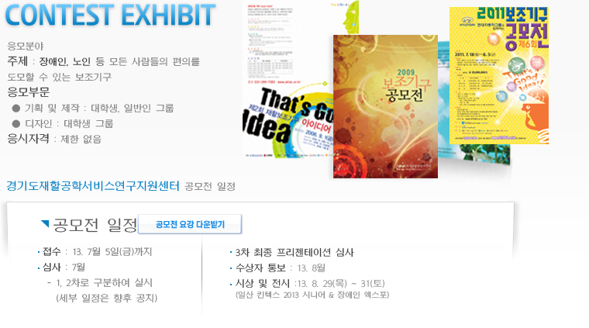

http://www.atidea.or.kr/bbs/board.php?bo_table=m21
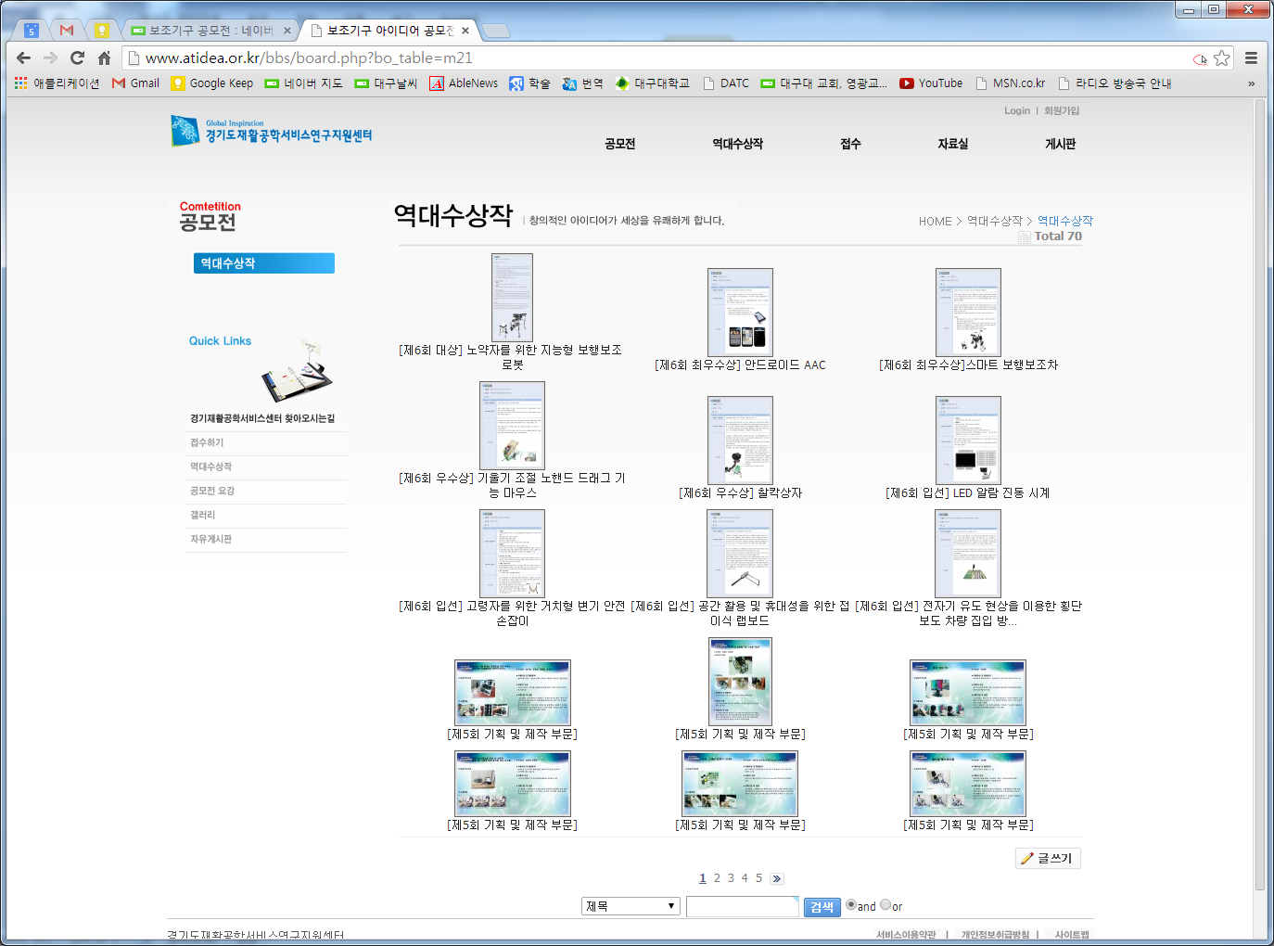
- i-CREATe student Design Challenge
http://atrac.or.kr/ 사진으로 다시 보는 [2013 국제 보조공학 심포지엄]

1. 보조기구 공모전 수상작 전시
- 일시 : 8. 29(목) ~ 8. 31(토), 3일간 전시
- 장소 : KINTEX 제 1전시장 3,4홀 內 독립 행사장
- 주최 : 경기도재활공학서비스연구지원센터
- 주요내용 : 공모전 수상작 부스 운영
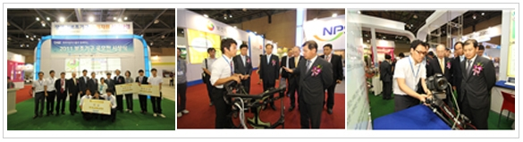

사진으로 다시 보는 [2013 국제 보조공학 심포지엄]

공모전 전시 부스는 제7회 보조기구 아이디어 공모전에서 수상한 작품들을 전시하고, 우리 직원들을 배치해 작품에대한 설명도 친절하게 해드렸습니다. 특히, 대학생들이 많은 관심을 보이며 공모전이 또 언제 하는지 물어보고 가는 경우도 있었답니다.
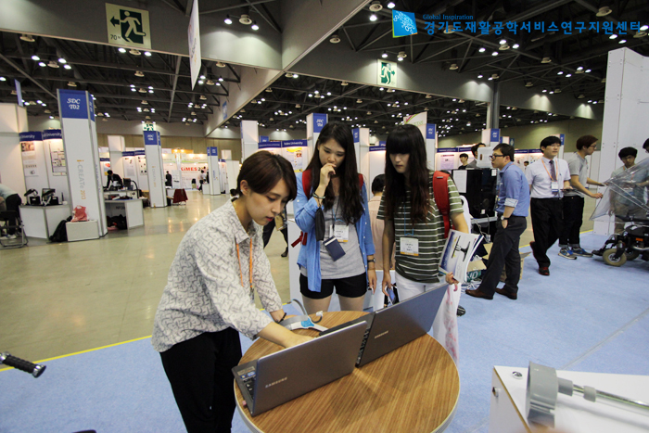

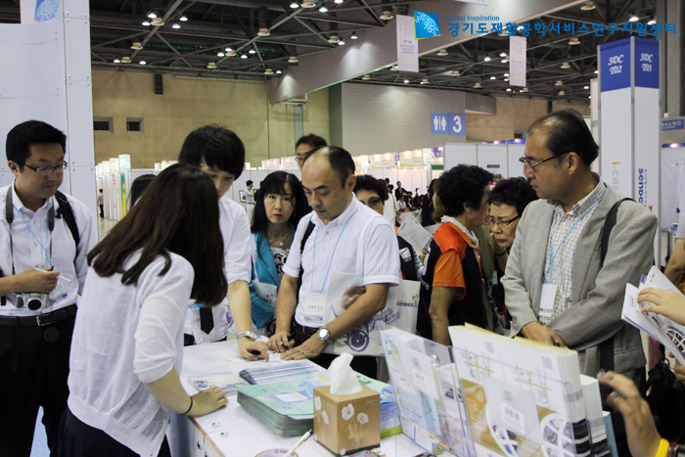

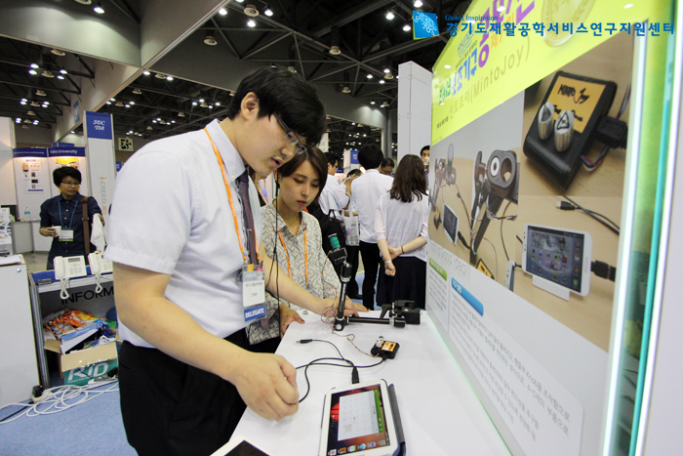

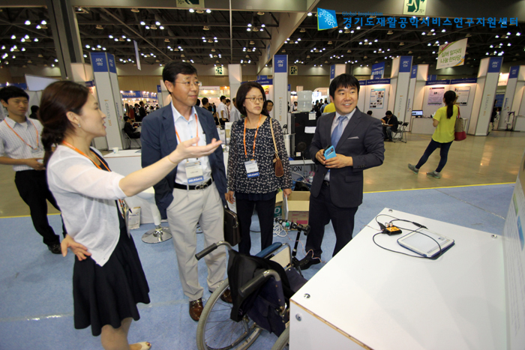

6th. SDC
http://www.icreateasia.org/images/stories/icreate2013/ProgramBookv19%20(AWT).pdf
(p60)

6th SDC winner
http://www.icreateasia.org/images/stories/icreate2013/SDC%202013%20Winners.pdf

https://7thicreate2013.shutterfly.com/activityfeed/7
7th i-CREATe 2013 in… (사진 앨범)

7th Student Design Challenge(2014)
http://www.icreateasia.org/index.php?option=com_content&view=article&id=162&Itemid=207

Submission is now open! Closing date for submission is 5th May 2014
Please submit your Entry form via email to sdc[at]icreateasia.org
Click here to download Entry Form
What is the Student Design Challenge (SDC)?
The Student Design Challenge encourages students to find creative and innovative solutions to improve the quality of living of elderly and people with disability. There are 2 category in this challenge.
Design Category
Student Students entries are expected to apply User-Centric Design process to develop solutions for assistive or rehabilitation applications. The proposed solutions need not have technological components but must be technically feasible. An illustration, in the form of drawing, 3D model, video, animation or functional prototype, is mandatory to illustrate the proposed.
Technology Category
Students entries are expected to apply principles in engineering and information technology to design and implement Assistive & Rehabilitative Technology solutions to address the issues / problems faced by the needy, their caregivers and clinicians. A functional prototype is mandatory to demonstrate the proposed solution.
Judging Guidelines for Technology Category
Creativity / Idea Novelty (20%)
Impact on Society and/or Professional Practice (20%)
Commercialization Potential (20%)
Prototype Engineering (20%)
Usability / Ergonomics (20%)
click here for details
Judging Guidelines for Design Category
Creativity / Idea Novelty (20%)
Impact on Society and/or Professional Practice (20%)
Commercialization Potential (20%)
Prototype Design and Implementation (20%)
Usability / Ergonomics (20%)
click here for details
Competition Requirements
This challenge is open to post-secondary education, undergraduates and postgraduates. These include Universities, Polytechnics and Institutes of Technical Education students. Submissions are invited from all students at all stages of their academic studies.
There is no limit to the number of teams that may compete from any given academic institute and each team is allowed to have up to 4 members.
Entries submitted should not exceed two years of development. All participants must provide proof that they are students at the time of work for the challenge was conducted.
Successful teams must bring their prototypes for the presentation. Large prototypes that are not transportable will be taken into consideration during the judging.
Selected entries will be notified by emails and are required to register for i-CREATe.
Competition Guidelines
- Individual / teams will submit the Entry form to sdc[at]icreateasia.org. Expert reviewers will evaluate submissions to be selected to attend the final Student Design Challenge at i-CREATe convention
- Selected teams will be expected to attend the convention with an A1 size poster outlining their design and innovation. Prototypes will have to be displayed together with the posters at the convention to a panel of Student Design Challenge Judges.
- The finalists will be given 5 to 10 minutes oral presentation on their design to the panel of the Student Design Challenge Judges and i-CREATe convention attendees.
- Based on the judging criteria, the judges will rank and identify overall winners of the competition.
Awards
 | Design | Technology
Champion | USD 1400.00 and certificate for all members | USD 1400.00 and certificate for all members
1st Runner-up | USD 700.00 and certificate for all members | USD 700.00 and certificate for all members
2nd Runner-up | USD 350.00 and certificate for all members | USD 350.00 and certificate for all members
Merit award | Certificate for all members | Certificate for all members
Intellectual Property
Kindly take note that i-CREATe will not have any involvement concerning Intellectual Property (IP) protection. Like other academic conferences or competitions, it is the participating institution's responsibility to protect their IP before disclosing their projects.
Student Design Challenge 2013 Result
Student Design Challenge 2013 Winners List
Enquiry
For Student Design Challenge enquiry, please contact:
Student Design Challenge Committee
Tel: (65) 6694 3402
Fax: (65) 6694 3403
Email: sdc[at]icreateasia.org

- RESNA
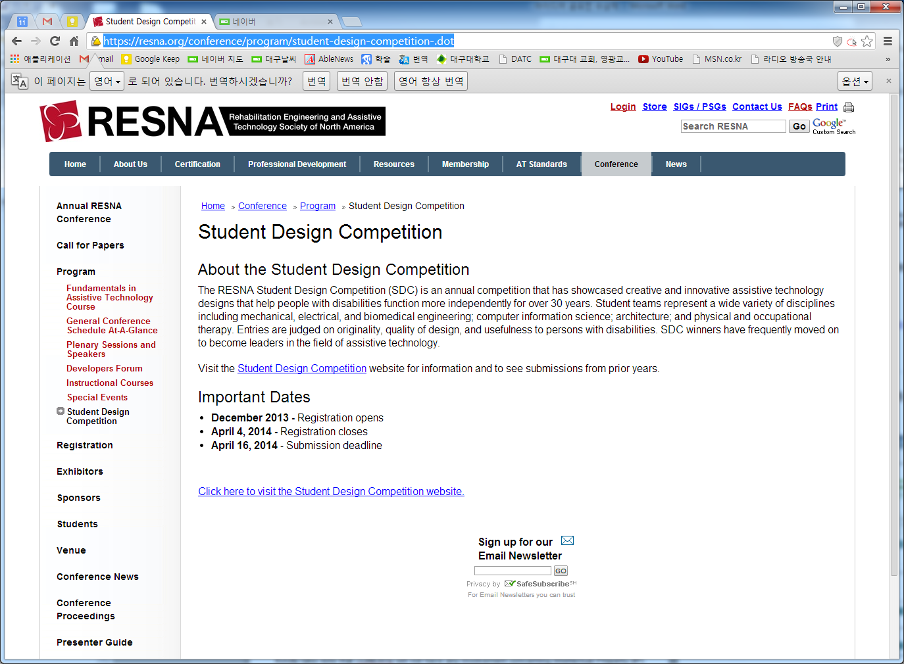
https://resna.org/conference/program/student-design-competition-.dot

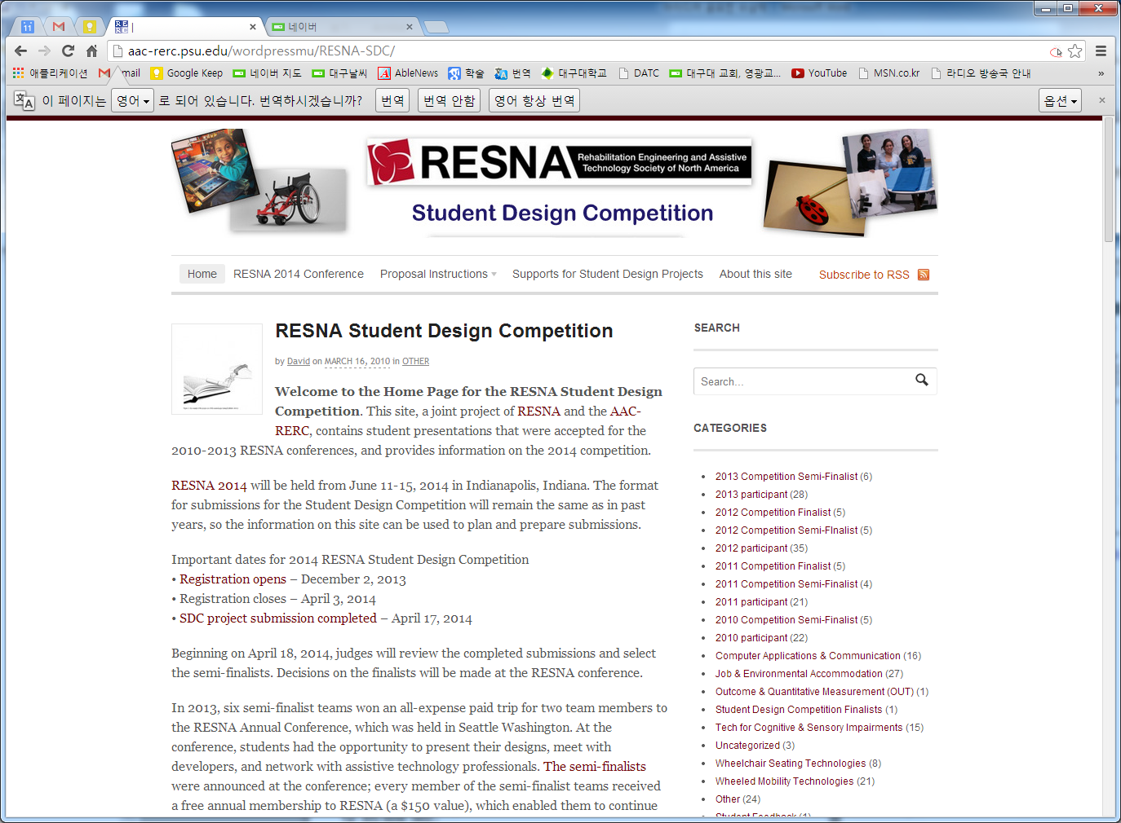
http://aac-rerc.psu.edu/wordpressmu/RESNA-SDC/

- Abledata
http://abledata.com/abledata.cfm?CFID=26160394&CFTOKEN=7583ad48c27db9c0-DEA52060-C4F8-24D1-D29E7C5C9F9B60CF
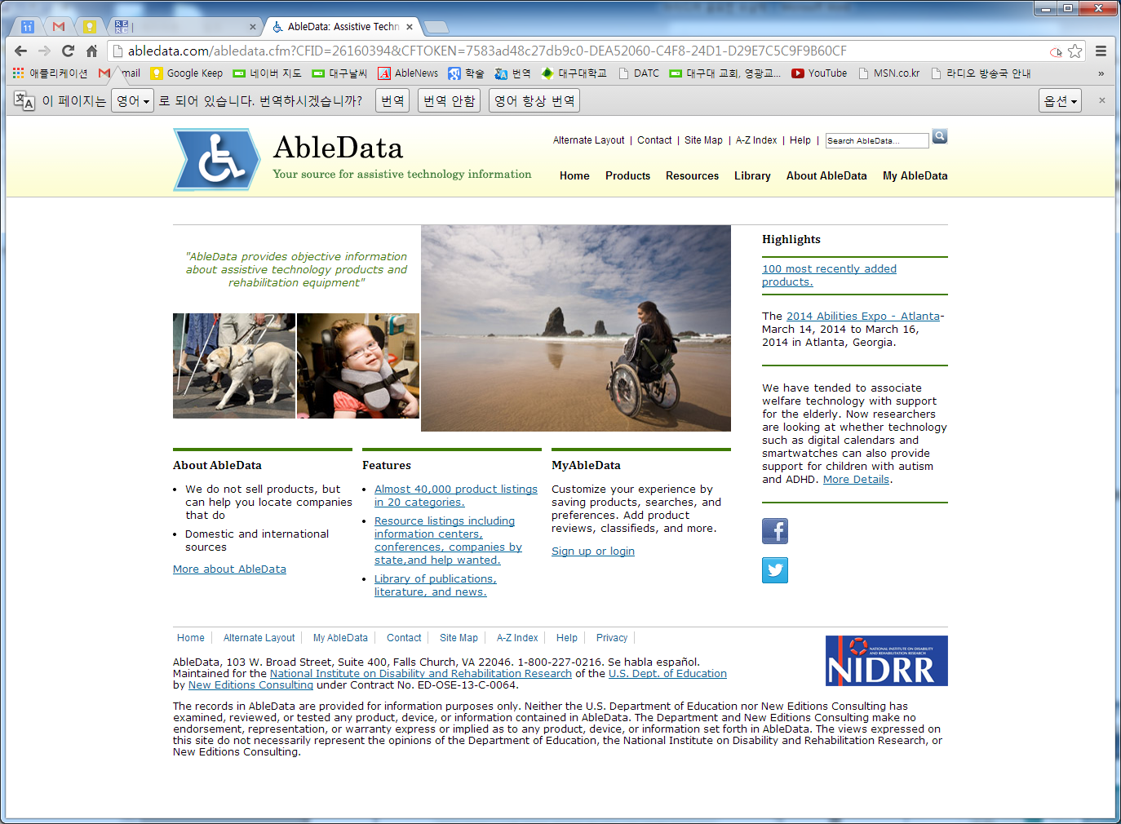
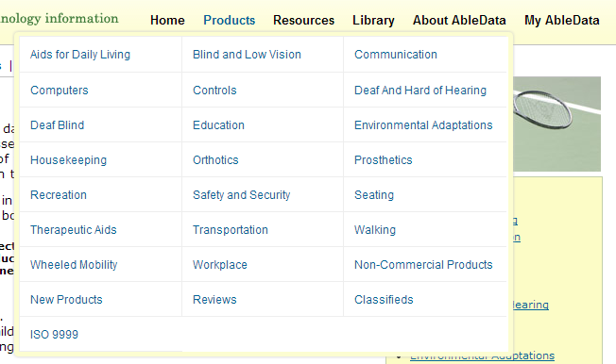

- 장애인 보조기구 사례관리시범사업
-장애인 보조기구 품목 및 분류 체계
http://rtdb.nrc.go.kr/
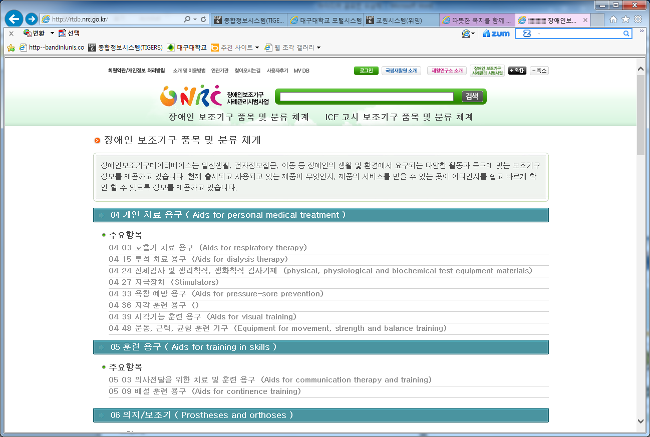

- 
http://www.atrac.or.kr/sub02/sub01.html
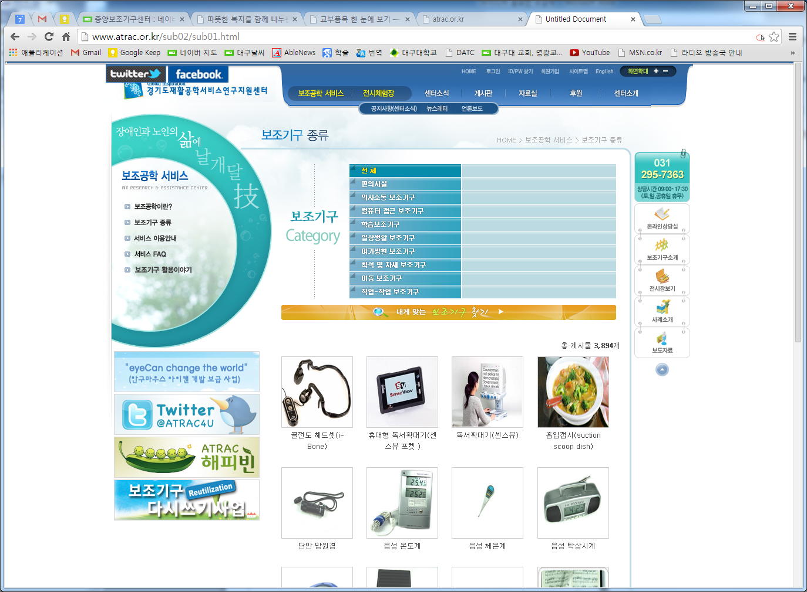

- 에이블몰
http://www.ablemall.co.kr/
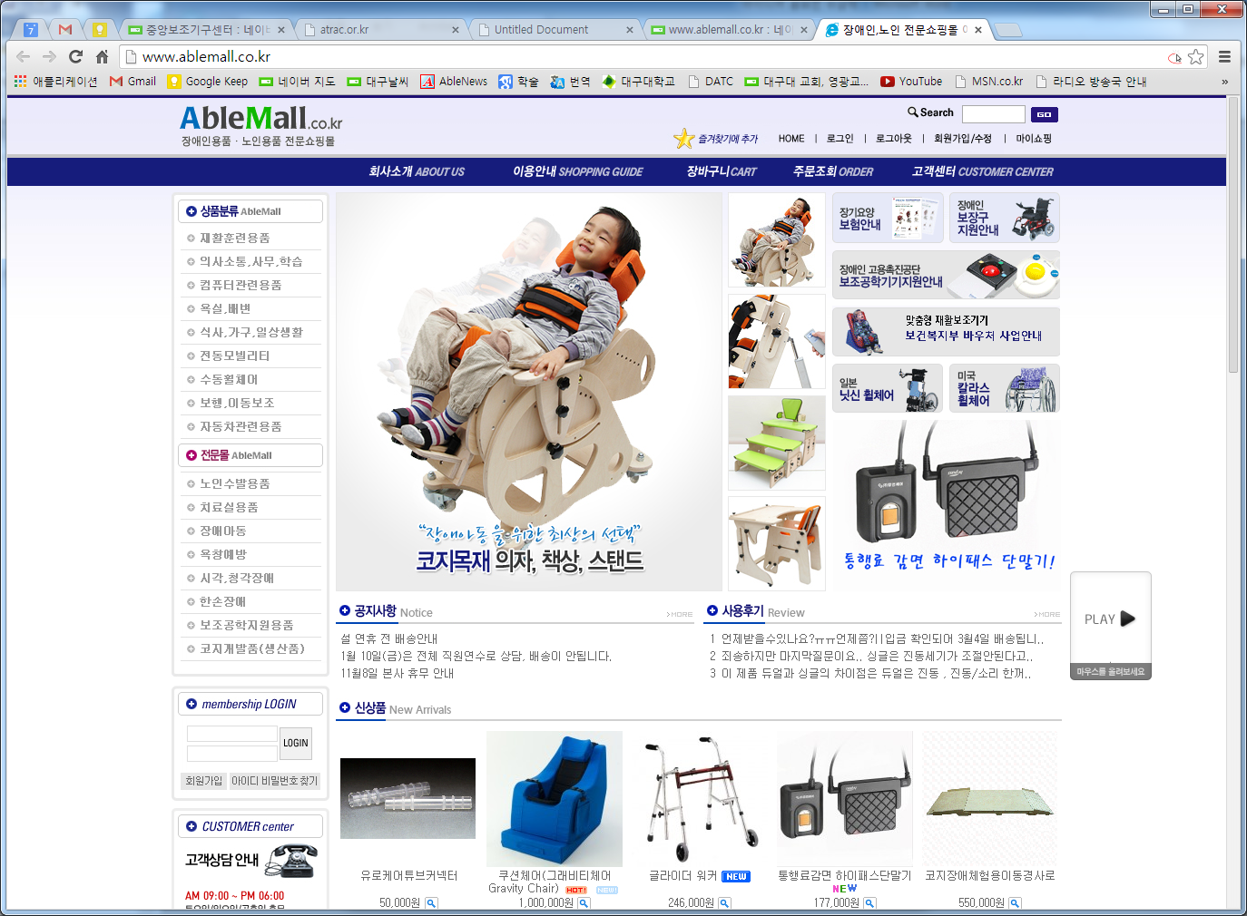

*** http://rst.daegu.ac.kr/

