Preparation of cultured cells for transmission electron microscope (TEM)
2015.03.13_Modified by Kim
Chemical Fixation (4ºC)
- Grow cells on cover slips in 6 well plates.Centrifuge cells after harvest from plates
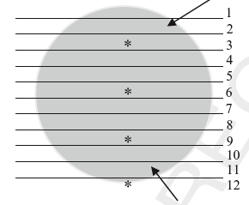1-mm-thick slices using scissors
- Put slices in glass vial
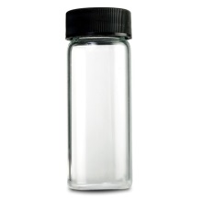
- Fix the monolayers in 2~2.5% Glutaraldehyde (Electron Microscopy Sciences, Cat#. 16210) in 0.2M phosphate buffer or Cacodylate buffer (Final concentration: 0.1M)
» 25% Glutaraldehyde, 1ml + 0.2M phosphate buffer (pH7.2), 5ml, Ultrapure water, 4ml (Total=10ml/20-25ml size bottle)
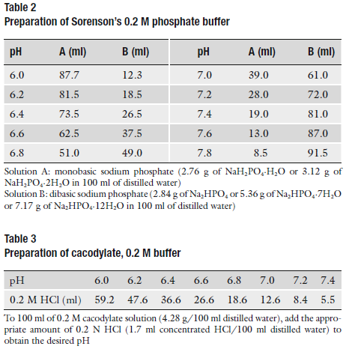
- Put the bottle in freezer for 3hrs and shake every 30min.
Post-fixation (4ºC)
- Wash with 0.1M phosphate buffer (pH7.2) twice for 5 min.
- Fix the slices in post-fixation buffer for 60~90 min.
» Reduced osmium tetroxide post-fixation: Mix 2~4% osmium tetroxide in water and 0.2M phosphate buffer (pH7.2)
» Post-fixation buffer: 2% osmium tetroxide (OsO₄), 2ml + 0.2M phosphate buffer (pH7.2), 1ml, Ultrapure water, 1ml
- Wash with 0.1M phosphate buffer (pH7.2) twice for 5 min.
Dehydration (4ºC~RT)
- 50% ethanol, 5 min; 70% ethanol, 5 min; 80% ethanol, 5 min; 90% ethanol, 5 min; 95% ethanol, 5 min; 100% ethanol, 5min
Embedding
- Dip the cover slips into propylene oxide (or acetone) for 5 min.
- Immediately drop some epoxy resin (Epoxy:Propylene oxide=1:1) to the cover slips in bottle.
- The samples have completely evaporated for 4 h using vacuum desiccator.
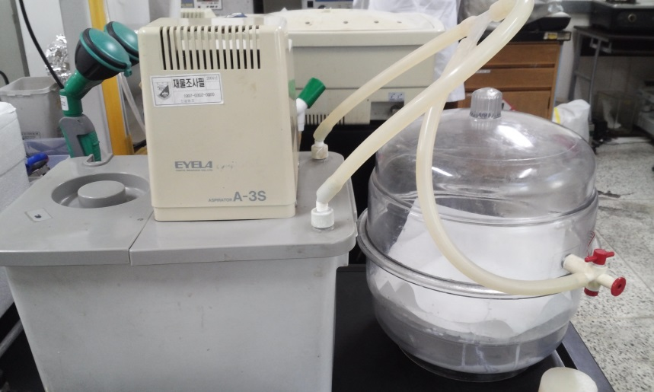
- Change the epoxy resin to new epoxy resin (Epoxy:Propylene oxide=2:1)
- Evaporate for 4h using vacuum desiccator.
- Change the epoxy resin to new epoxy resin (Pure epoxy) and evaporate for 4h

Polymerization
- Fill flat embedding mold (or beem capsules, embedding capsules) with epoxy resin and place samples on the epoxy resin
- Fill it up with epoxy resin into tray
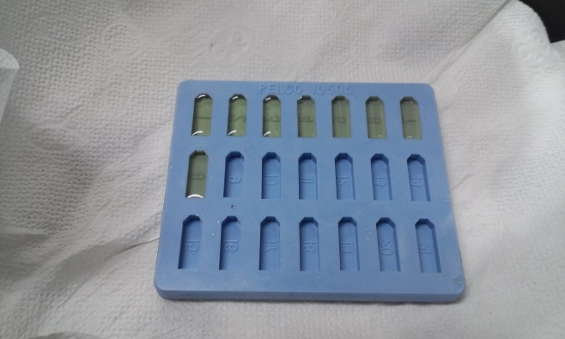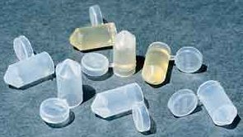
- Incubate at RT for 2h
- Polymerization the resin at 37 ºC overnight (over 24 h)
Ultrathinsection
Trim the block to a pyramid of desired size and directly start cutting 70- to 80-nm thin sections. Remember the sample is only one cell layer thick; therefore, it is not recommended to trim the block face before cutting thin sections.
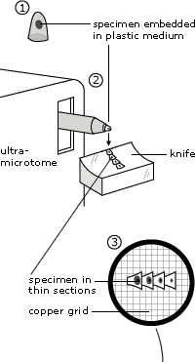
Staining
Stain the sections with uranyl acetate (20~30 min) and lead citrate (10 min). Wash the samples with D.W (X3) after each staining.
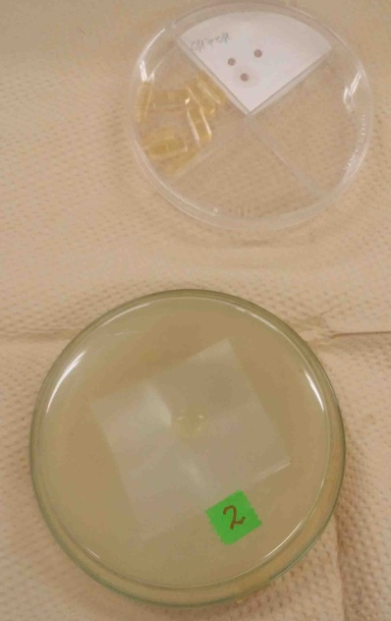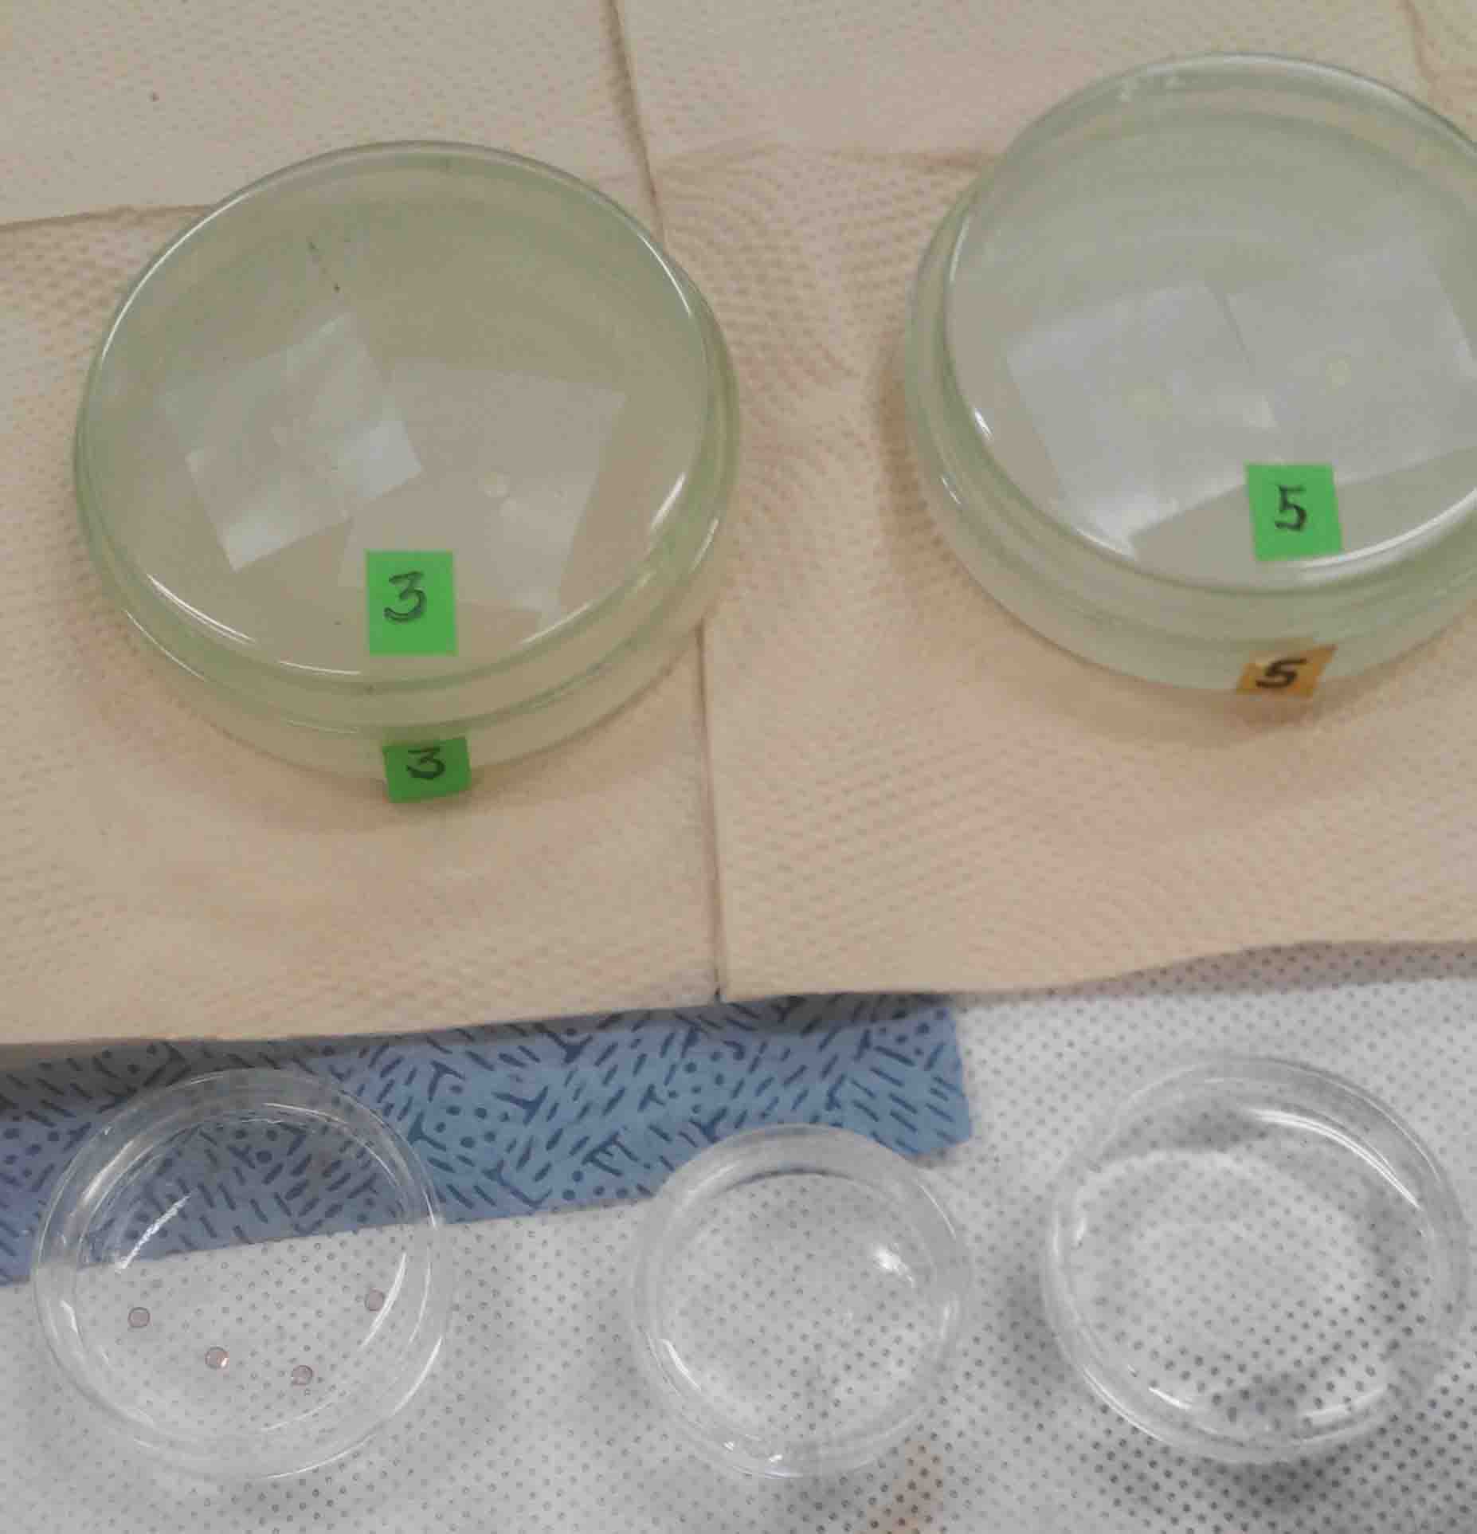
- Drop 2-3% uranyl acetate on parafilm and cover cap to avoid air contact
- Sample side down to solution
- Stain the Glid with 2-3% uranyl acetate in UFwater for 20 min
- Washing three times
- Air dry the glid for 10 min
- Drop 0.3% lead citrate on new parafilm with NaOH
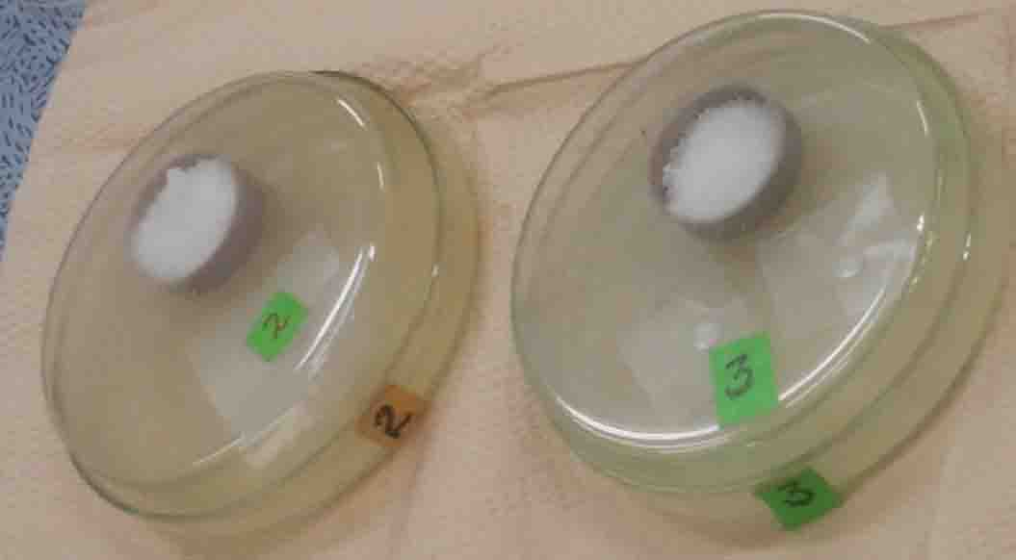
- Stain the Glid for 10 min
- Washing three times
- Air dry the glid for 10 min

Observation
Yeungnam University
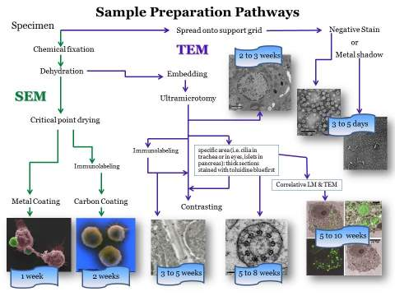
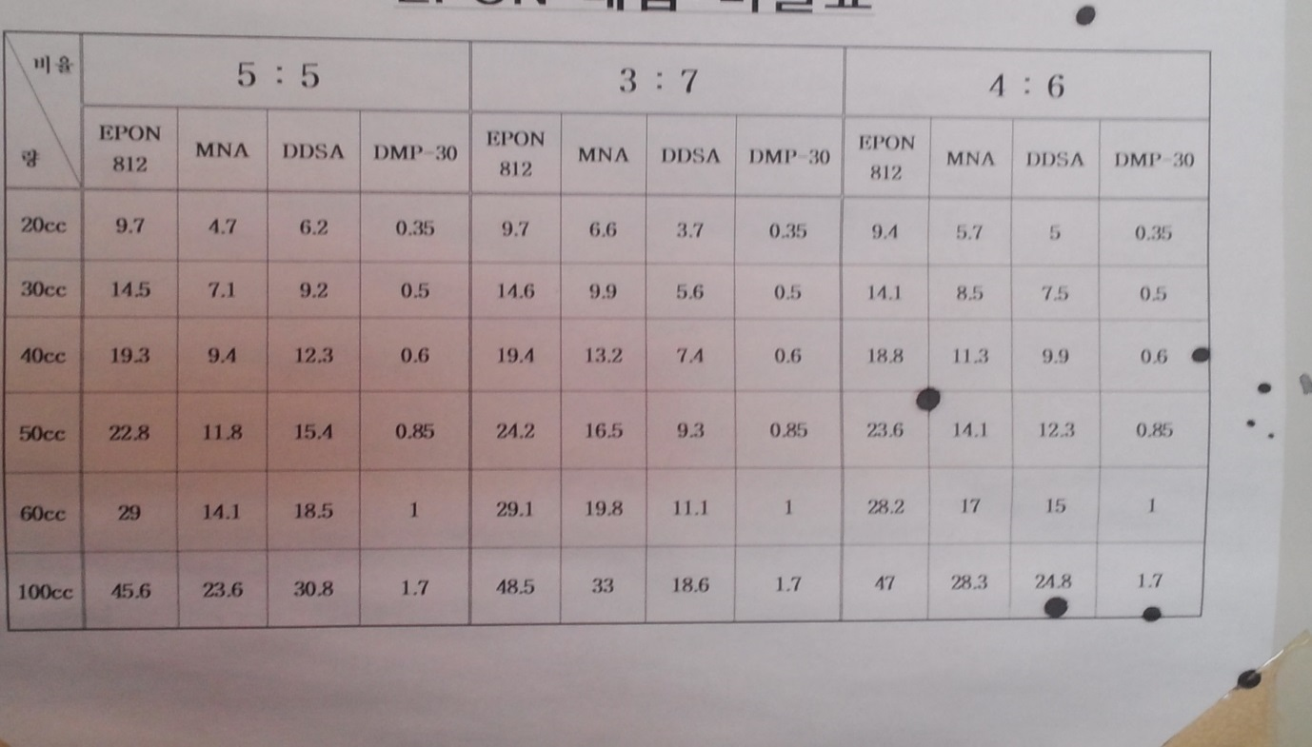
EPON: Eponate 12 resin (Glycerol Polyglycidyl Ether), TED PELLA, INC. (Cat#. 18005)
NMA: Nadic Meyhyl Anhydride (Methyl-5-Norbornene-2,3-Dicarboxylic Anhydride), Electron Microscopy Sciences (Cat#. 19000)
DDSA: Dodecenyl Succinic Anhydride, Electron Microscopy Sciences (Cat#. 13700)
DMP-30: Electron Microscopy Sciences (Cat#. 13600)

