Confocal microscopy (Carl Zeiss LSM 700 in KNU)
Modified by Kim (2015.03.20)
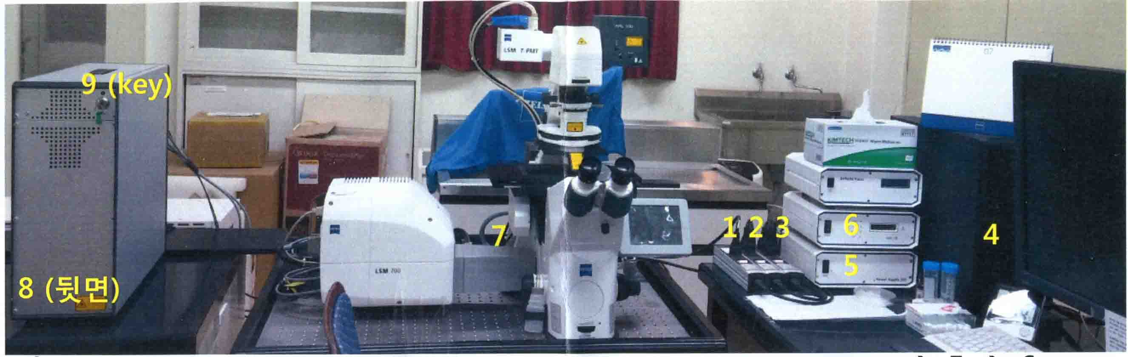
- Switch on the button from 1 to 3 and wait just moment to see light on power buffer in computer and continuously switch on the button from 4 to 9 (turn the laser key on to 3h position (90º clockwise)).
- Double click ZEB 2009 software icon on the desktop of WINDOWS to start the software programs. 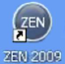
- Click start system (Do not double click)
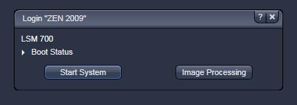
- Secure the slide/dish on the platform with cover slip facing downwards.
- Click “Ocular” then “Online” to enable the specimen to be viewed through the binocular, and select appropriate objective to examine the slide/dish.
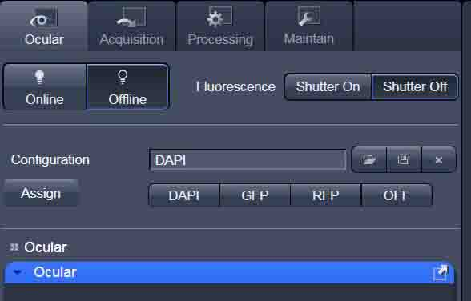

- First, you check the signal using DAPI and you make sure which position you look at it.
- Next, you check another signals RFP (Red, eg. Mitotracker), GFP (Green, eg. UCP1)
- Click “Offline” then move to “Acquisition” mode.
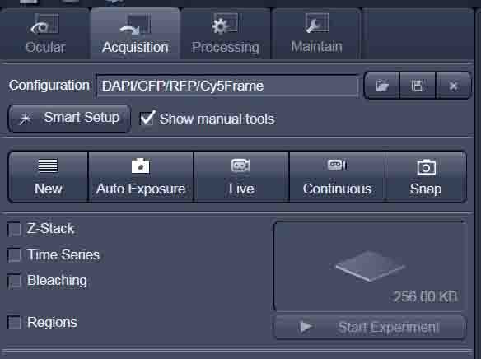
- Click “Smart Setup” at “Acquisition” mode.
- Set up the experiment as instructed below, and click “Apply”
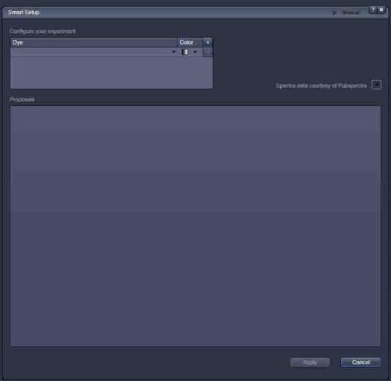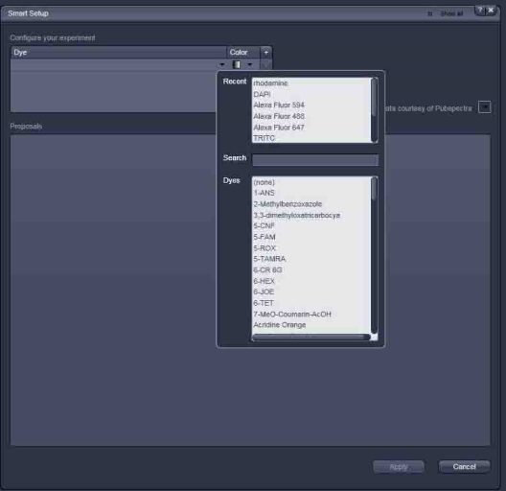
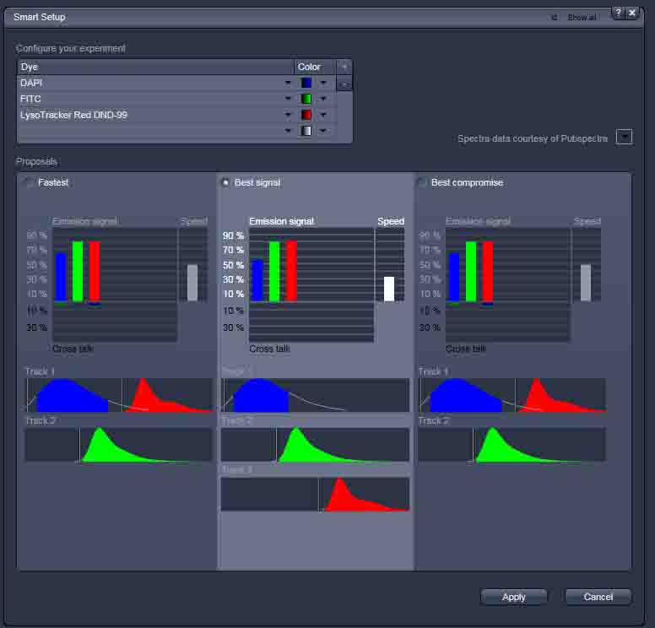
- Click “New”
- You can apply Averaging (Methods:Frame/Line; number 2-16)
Averaging Number “16”, “Frame” for fixed cell, “Line” for living cell.
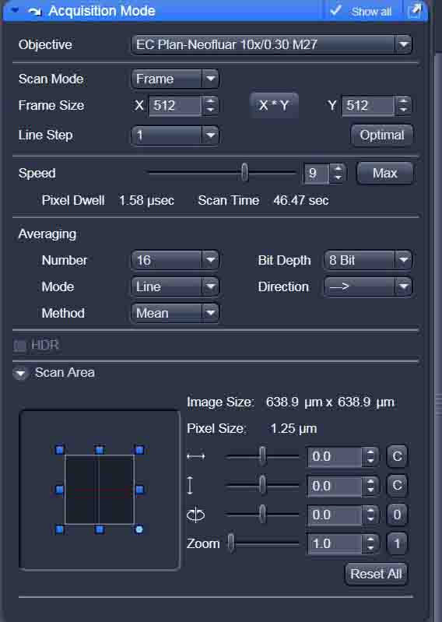
Bit Depth (8 for a standard image, 12 for co-localization, ratio or for de-convolution)
You can change the “Zoom” factor (0.5 for down magnification or 2 for up magnification)
Select the “Frame size” from the default size via the drop down menu (click the XY) button. Recommended setting to start with 512*512
Scan Speed “8-9” is a good starting value.
- Click on the “Channels” Menu. Click the “Select all” if you want to see all channels
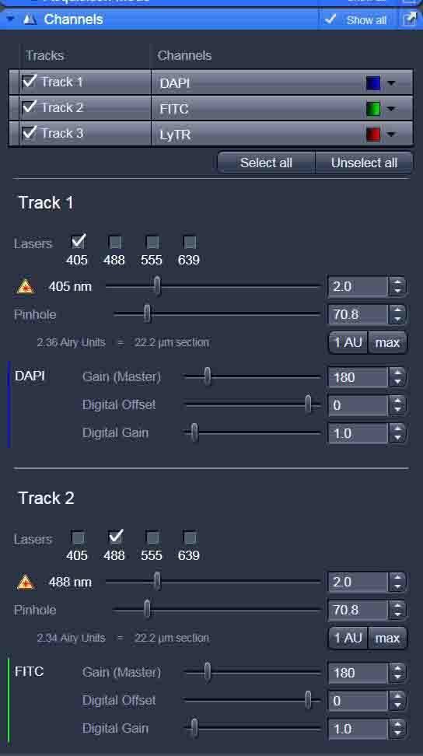
Output intensity of the lasers: from 0.2-100%. Usually 2-15% should be enough for “normal” imaging.
Pinhole: 1AU
Gain (Master): 600-800 (NOT to use too extreme settings,>800 mV)
Digital Offset: To reduce the background
Digital Gain: 1 (maximum 3)

- Click “Live” to see the preview of the sample. 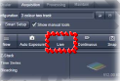
Control the value of “Laser intensity, Gain, Digital Gain” for clean images
In case of multiple channels: “Split” your image
- Click “Stop” to complete the preview of the sample.
- Click “Snap” to take images
- You can use “Crop” button to Zoom In on specific area.
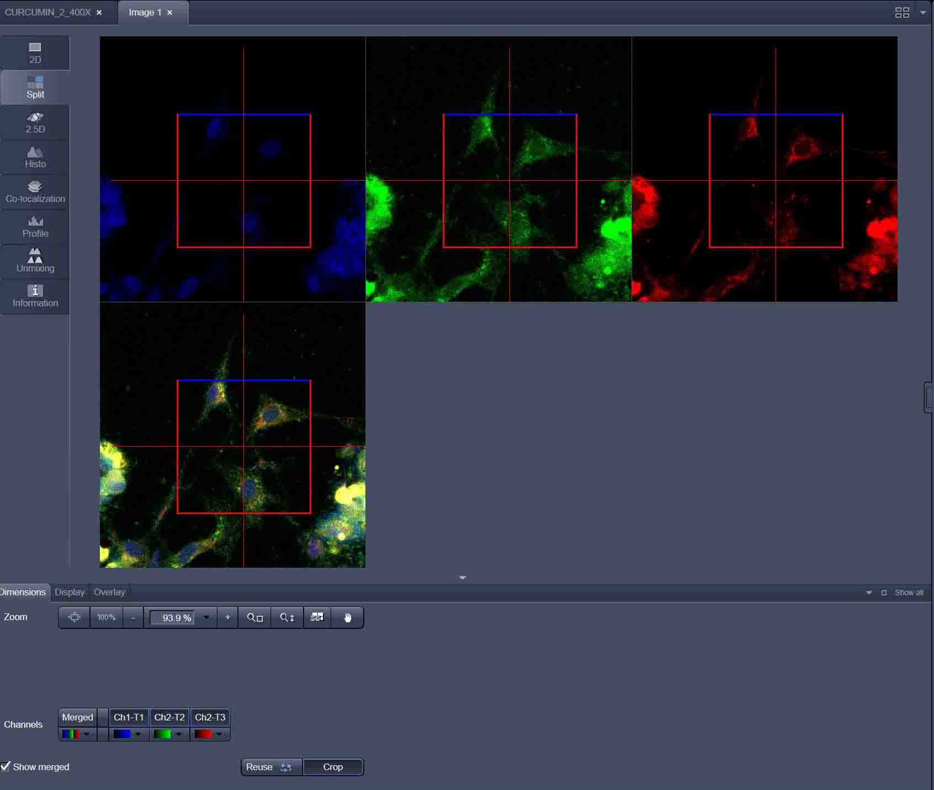
- Save the image to “lsm” and it can be export to “JPG or TIF”.
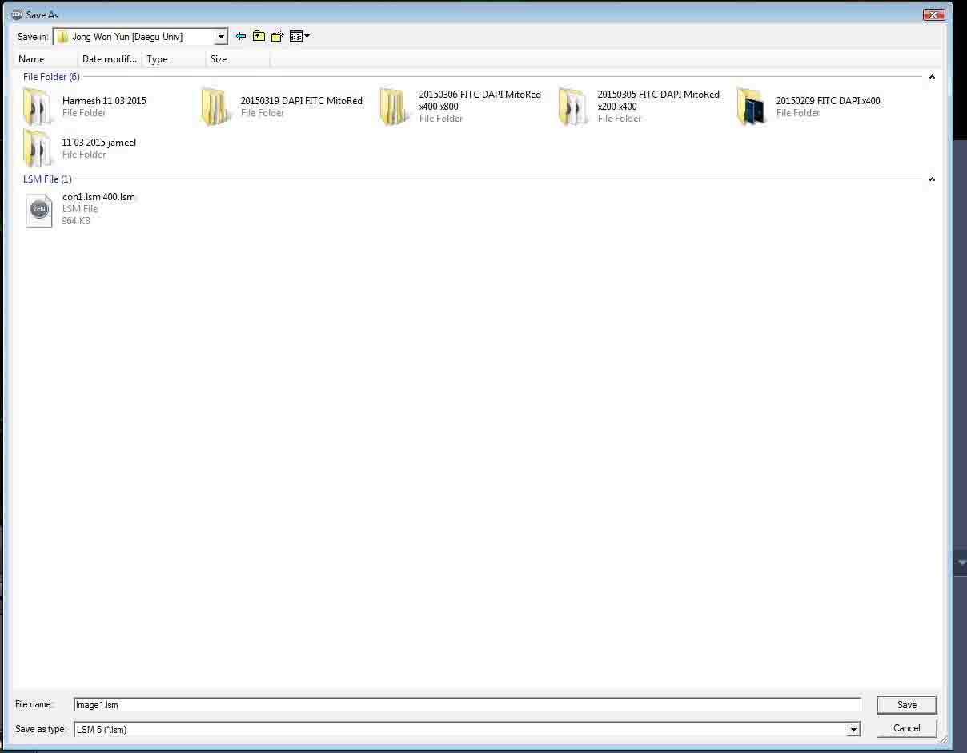
- When you done. First, you have to close system of computer.
- Switch off the button from 9 to 1. For 9 (turn the laser key on to 12h position (0º clockwise)).
- Clean up the lens with lens papers
